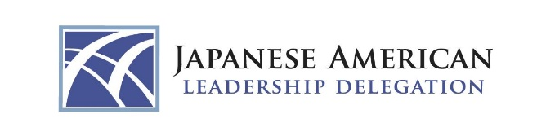

2024 JAPANESE AMERICAN LEADERSHIP DELEGATION TO JAPAN
21st DELEGATION

APPLICATION

Individuals selected must be able to travel to Japan from March 1 (Fri) – 9 (Sat), 2024 and
attend a mandatory orientation in Los Angeles from Jan 29 (Mon) – 30 (Tues), 2024. Deadline for application submission: Sept 15, 2023.

REQUIRED MATERIALS
All materials must be submitted by the above deadline in order for the application to be considered.

1) Resume:
Please submit a resume no longer than 3 pages in length. If the following information is not included in your resume, please provide an additional attachment.

- Date of Birth
- Address – Business and Home (Specify preferred mailing address)
- Telephone – Business, Home, Cell Phone
- Email Address
- Employer
- Job Title
- Job Field
- Professional Affiliations & Leadership Positions
- Community/Volunteer Affiliations & Leadership Positions
- Prefecture(s) in Japan where your ancestors originated
- Nikkei ancestry generation in U.S. (sansei, yonsei, shin-nisei, etc.)
- Prior visits to Japan if applicable (Specify year, length of stay and purpose of visit)
- Have you previously applied to the program? (Specify year)
- How did you learn about this program?
- References (Two): Preferably individuals who are knowledgeable about your experience in U.S.-Japan relations and/or your professional/community/volunteer experience.

2) Biography:
Please include a short (150 word) narrative biography highlighting your career, community involvement, and education.
Examples from previous classes may be found at www.usjapancouncil.org/jald.

3) Personal Statement:
Provide a brief essay (no more than three pages, attached as a separate document) addressing the following:

- Why do you wish to participate in this program?
- Briefly describe any prior experience you have had in U.S.-Japan relations.
3. In 2024, Japan will be preparing to welcome guests from around the world for the Expo 2025 Osaka, Kansai, with the theme "Designing Future Society for Our Lives." How can you make a difference in the context of U.S.-Japan relations?

4) Letter of recommendation:
Please submit a recommendation letter in support of your application (limit two, additional letters will not be considered).

All information should be sent by email to:
1) Your local Consulate General of Japan (see attached list). Residents of Washington, D.C. should send their information to the Embassy of Japan.

2) Applicants are also required to send a copy to the U.S.-Japan Council via e-mail to amurata@usjapancouncil.org.

All applicants will be notified of the results by the consulate general or embassy to which they submitted their application, generally by the end of November.

For more information contact:

Embassy of Japan/Consulate General of Japan in your region
(see attached for list of Embassy of Japan and Consulate offices)

Consulate General of Japan in Los Angeles
Ms. Jennifer Usyak, j.usyak@ls.mofa.go.jp, (213) 617-6700 x166
Consul Aya Ishii, aya.ishii-2@mofa.go.jp, (213) 617-6700 x303

U.S.-Japan Council
Ms. Wendy Abe, wabe@usjapancouncil.org, (808) 271-0817 or
Ms. Allison Murata, amurata@usjapancouncil.org, (202) 750-4030

