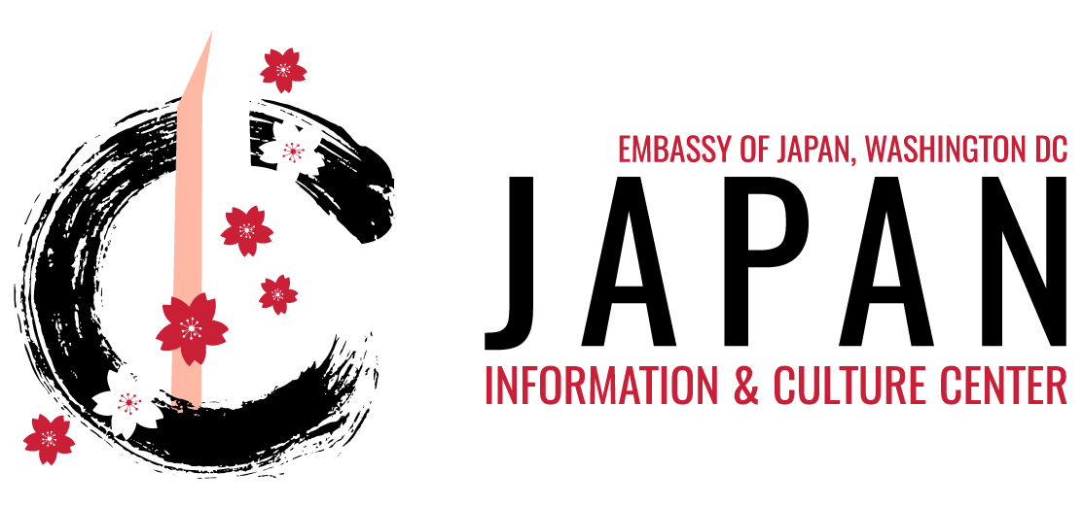

**EDUCATIONAL PROGRAM RESERVATION FORM**

Please fill out the following form and send it via attachment to the Educational Programs Coordinator, Ms. Gabrielle Headly, at [gabrielle.headly@ws.mofa.go.jp](mailto:gabrielle.headly@ws.mofa.go.jp).

**Please keep in mind:**

* Food and drinks are not allowed inside the JICC.
* **Please do not visit** if you currently have a fever or cold/flu symptoms; and/or if you have experienced or been in contact with a confirmed COVID-19 case in the last 14 days.

**Preferred Dates & Time *Must be during our business hours. Mon.-Fri. 10a.m. to 4 p.m. (Choose Two):**

Click here to enter a date.Click here to enter a date.

**School or Organization Name and Address:**

Click here to enter text.

**Contact Person and Email Address:** Click here to enter text.

**Phone number (for emergency contact purposes):** Click here to enter text.

**Number of Students & Chaperones:** Click here to enter text.

**Grade(s) of Students:** Click here to enter text.

**Cultural Activity Options (Highlight): Please indicate which hands-on cultural activity you would be interested in pairing with your educational program.**

1. No activity, Presentation only (1 hr.)
2. Japanese folktale story time (20 min., K-5)
3. Origami, Art of Paperfolding (30 min., All ages, Max. 30 participants)
4. Suminagashi, Water Marbling (1 hr., 5th grade +, Max. 26 participants)
5. Rubberstamp Making (1 hr., 7th grade +, Max. 20 participants)
6. Inquire about seasonal activities!

**Have you participated in an Educational Program at the JICC before? If not, how did you hear about us?** Click here to enter text.

**1150 18th Street, Suite 100, NW, Washington, DC 20036・Tel: (202)-238-6900**

**http://www.us.emb-japan.go.jp/jicc/index.html**

**Additional comments, questions, or requests:**

Click here to enter text.

**Please read the following and choose “YES, I Agree” or “NO, I Disagree”.**

**YES, I Agree**

**By submitting this form the organizer hereby gives permission for the Japan Information and Culture Center (JICC), Embassy of Japan to use their school or group’s name, any photographs and/or video taken of the participants during the presentation to be used in promotional materials, media, articles or otherwise without additional permission or release.**

**NO, I Disagree**

**1150 18th Street, Suite 100, NW, Washington, DC 20036・Tel: (202)-238-6900**

**http://www.us.emb-japan.go.jp/jicc/index.html**

**Thank you for your request. You will be sent a confirmation letter after your request has been processed which may take a few days.**