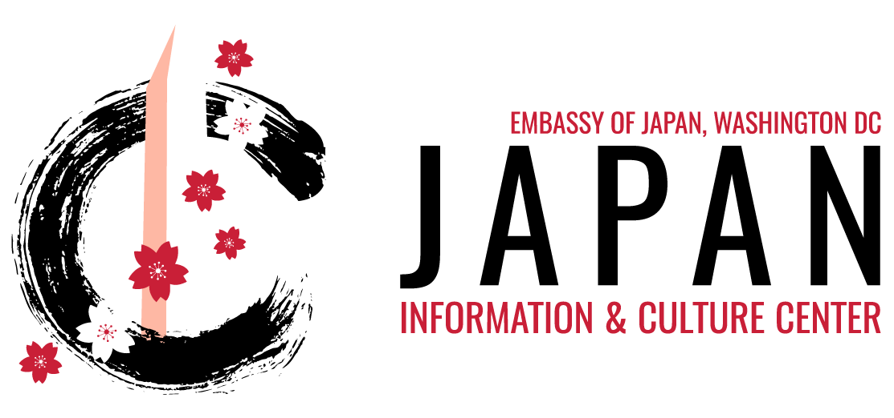

**ITEM LOAN REQUEST FORM**

Please fill out the following form and send it via attachment to [jicc@ws.mofa.go.jp](mailto:jicc@ws.mofa.go.jp).

**Preferred Pick-Up Date & Time:**

**JICC Artifact Set:** This all-in-one set includes the items listed below. If you would like to request more of a particular item, please specify in the next section.

* **[1] Japanese Flag**
* **Traditional Games: [2] Kendama and [1] Daruma Otoshi**
* **Traditional Garments:**
  + **[2] Happi (Circle size: Adult S, Adult M, Adult L or Child)**
  + **[1] Yukata (Circle size: Adult or Child)**
* **Fake Food (Selection will be based on availability)**
* **[1] Kamishibai Storybook**

**Additional Requests:** Please let us know if you would like to request more of any of the items listed above.

|  |  |  |
| --- | --- | --- |
| **Item Name** | **Qty** | **Special Requests** |
|  |  |  |
|  |  |  |
|  |  |  |
|  |  |  |
|  |  |  |
|  |  |  |
|  |  |  |

**Thank you for your request. A member of the JICC Team will be in contact with you after your request has been processed, which may take up to a few days.**